**Finding Lane Lines on the Road**

**Writeup Template**

**You can use this file as a template for your writeup if you want to submit it as a markdown file. But feel free to use some other method and submit a pdf if you prefer.**

**Finding Lane Lines on the Road**

The goals / steps of this project are the following:

* Make a pipeline that finds lane lines on the road
* Reflect on your work in a written report

**Reflection**

**1. Describe your pipeline. As part of the description, explain how you modified the draw_lines() function.**

My pipeline consisted of 5 steps. First, I converted the images to grayscale, then I ....

In order to draw a single line on the left and right lanes, I modified the draw_lines() function by ...

If you'd like to include images to show how the pipeline works, here is how to include an image:

[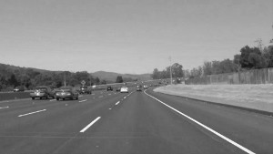](https://github.com/udacity/CarND-LaneLines-P1/blob/master/examples/grayscale.jpg)

**2. Identify potential shortcomings with your current pipeline**

One potential shortcoming would be what would happen when ...

Another shortcoming could be ...

**3. Suggest possible improvements to your pipeline**

A possible improvement would be to ...

Another potential improvement could be to ...